**JAVA Script Activity**   
  
Given a number ‘number’, assuming it’s ranging from 1 – 999, convert it into

words using **If.. else condition** or simply **if conditions** or **switch statement**.

**Sample input:** let number = 789;

**Sample output:** Seven Hundred Eighty Nine

let inumber = "";

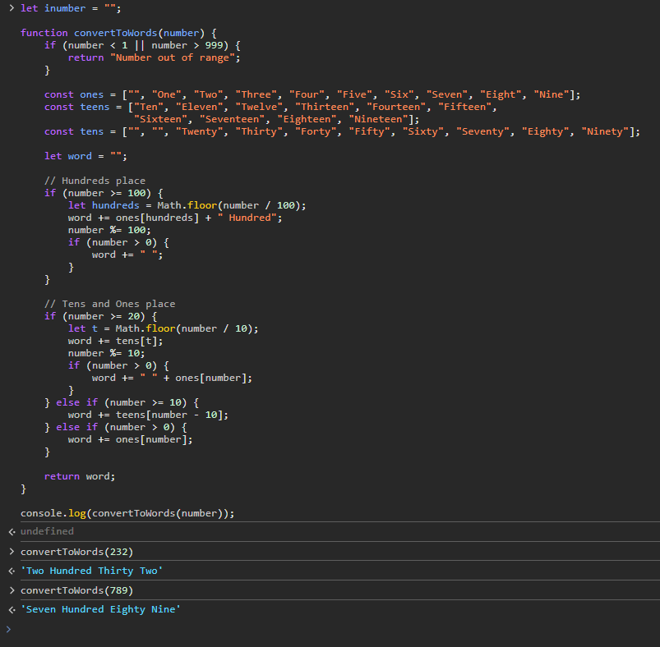

Using **While Loop**, print the pattern below. Given ‘height’ as height of the triangle and

assuming it is not a negative number.

**Sample input:** let height = 5; **Sample output: * * * * \***

* * * *

* * *

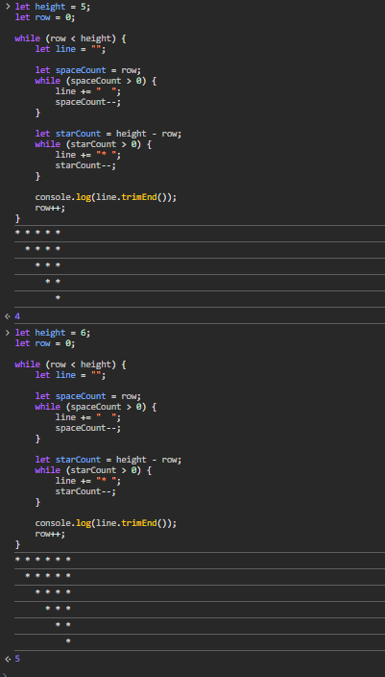   * *

*

Using **For Loop**, print the pattern below. Given ‘height’ as height of the ‘X’ sign and

assuming it is not a negative number and ‘height’ is an odd number.

**Sample input:** let height = 5;

**Sample output:**

* *

* *

*

* *

* *

Create a function that calculates the perimeter of a triangle. Function should return the value of perimeter.

We have the following arrays:

**color = ["Blue ", "Green", "Red", "Orange", "Violet", "Indigo", "Yellow "];**

**o = ["th","st","nd","rd"];**

Write a JavaScript program to display the colors in the following way:

* "1st choice is Blue."
* "2nd choice is Green."
* "3rd choice is Red."

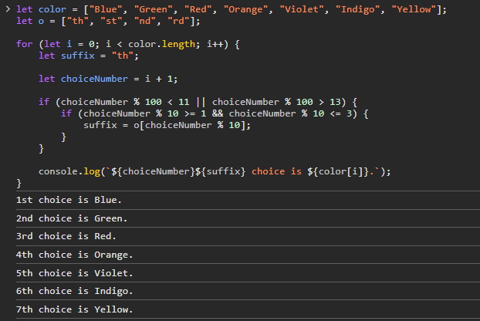

let record = [{

"Name":"Gibo",

"Age":16,

"SkillSet" : [{

"Skill":"SAP UI5"

},{

"Skill":"SAP HANA"

}]

}, {

"Name":"Patrick",

"Age":22,

"SkillSet" : [{

"Skill":"SAP UI5"

}, {

"Skill":"SAP HANA"

}, {

"Skill":"SAP ABAP"

}]

}, {

"Name":"MJ",

"Age":24,

"SkillSet" : [{

"Skill":"SAP HANA"

}]

}];

Given the data in slide 5, output the data(Name and Age) of the person with

the highest number of skillset.

Output: Name: Patrick

Age: 22

